**Instructions:**

Imagine that you are a tourist visiting a new city and want to use the subway system to get around. Unfortunately, the subway map you have is out of date, and several tracks on it are marked as “Under Repair”. As it might help get you around faster, you decide to ask a passer-by if any of these tracks have finished repair work.

Each of the images below represent a subway network, with the circles as stations and lines as tracks. For each subway system, there are 2 or 3 tracks in **red**, representing tracks that are possibly under construction. **Circle ONE track** whose repair status you want to find out about **the most.** There’s no need to think too hard about each map!

---

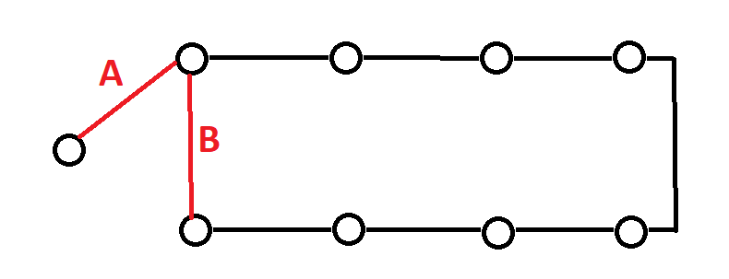**SUBWAY 1 SUBWAY 2**

**SUBWAY 3**

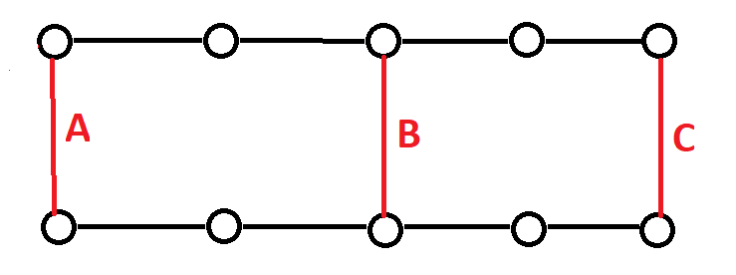

**SUBWAY 4**



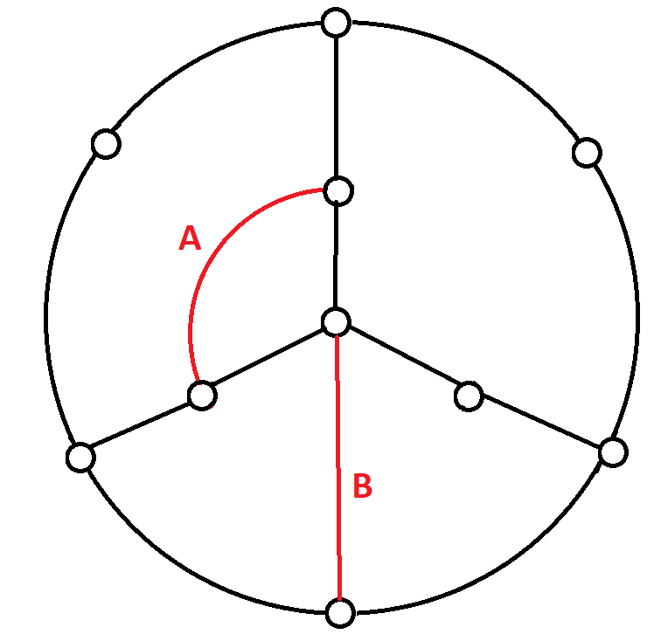 **SUBWAY 5**

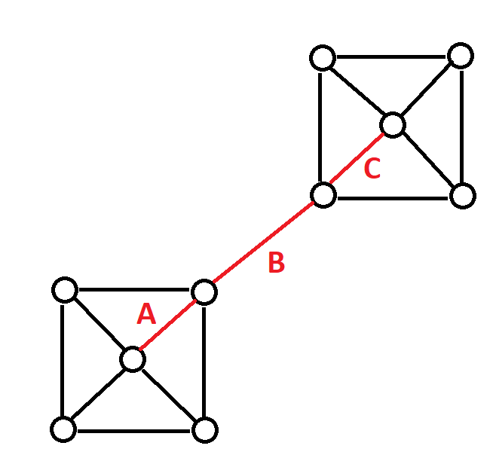 **SUBWAY 6**

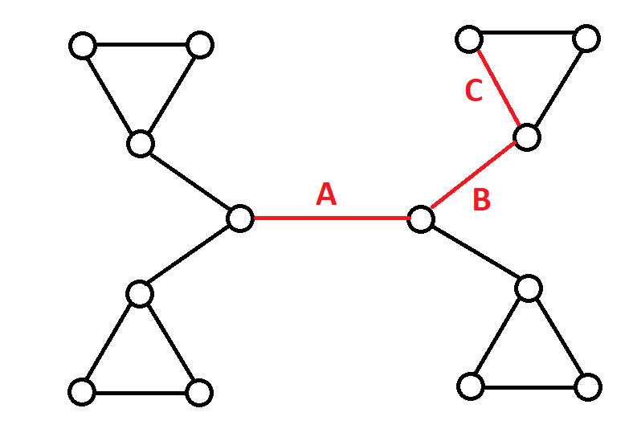**SUBWAY 7**